**Implementation of the Simple Router**

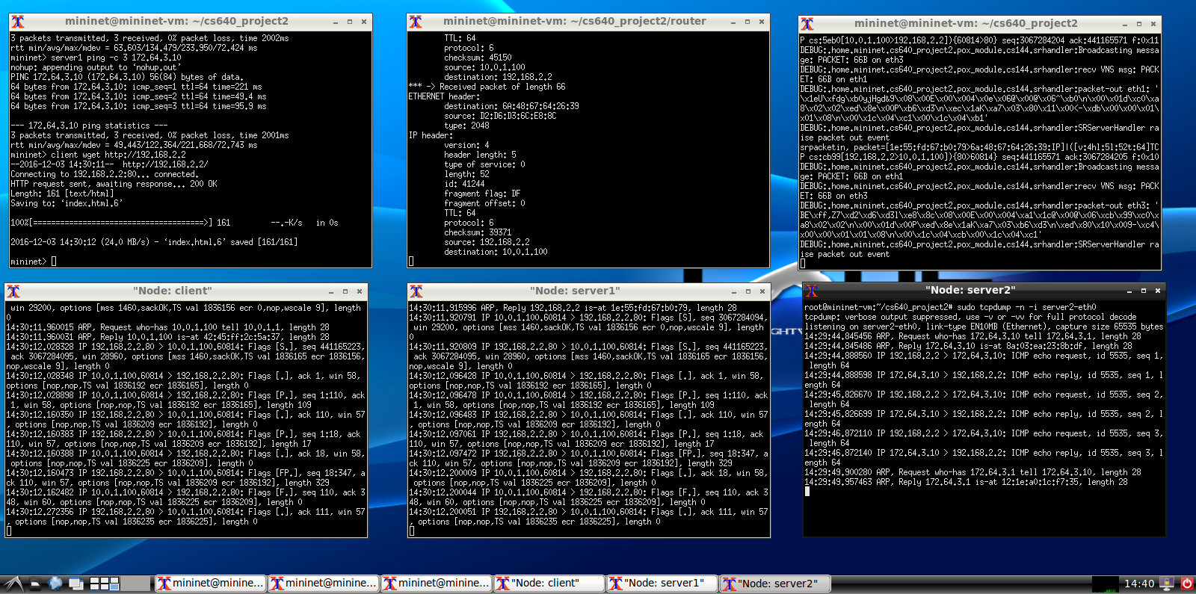

The top left corner terminal hosts the Mininet topology running. The topology consists of 3 hosts(client, server1, server2), a switch(sw0), and a controller(c0). This is where all the ping and wget commands should be typed. The top middle terminal is dedicated to the router and shows the packets being sent through it. The right terminal is dedicated to the pox controller which helps the router and Mininet topology communicate. The bottom terminals are all dedicated to listening to the tcp dumps of the client, server1, and server2 respectively.

**How to setup the Code.**

**In accordance to the directions on the website posted on blackboard do the following commands to get all of the support files needed for the router.**

**First open a terminal**

sudo apt-get update

sudo apt-get install -y python-dev vim-nox python-setuptools flex bison traceroute

cd ~

git clone git://github.com/dound/ltprotocol.git

cd ltprotocol

sudo python setup.py install

cd ~/pox

git checkout f95dd1a81584d716823bbf565fa68254416af603

**Now it is time to setup the router now that all the support documentation has been loaded. We kept the cs640_project2 file name since the router seemed to malfunction when we changed the folder name.**

**On the same terminal run.**

cd ~/cs640_project2/

./config.sh

./run_mininet.sh

**Open a new terminal and run the following to set up the pox controller.**

cd ~/ cs640_project2/

ln -s ../pox

./run_pox.sh

**Open a new terminal and run the following to setup the router**

cd ~/ cs640_project2/router/

make

./sr

**Go back to the Mininet terminal and this code to open up terminals for client, server1, and server2.**

xterm client

xterm server1

xterm server2

**Now go to each terminal for client, server1, and server 2 and right the respective commands to listen to the tcp dumps.**

sudo tcpdump -n -i client-eth0

sudo tcpdump -n -i server1-eth0

sudo tcpdump -n -i server2-eth0

**Now set up the terminals in the way designated in the terminal above.**

**You can now got to the Mininet terminal and run some of these sample commands to see the terminal in action.**

client ping -c 3 192.168.2.2

server1 ping -c 3 172.64.3.10

client wget http://192.168.2.2